# 301 Redirect Module

Updated: 10/15/2016

By: Chris Castle

Introduction

There are multiple ways to handle redirects with IIS, but these require access rights that most business users do not have. This module allows business users to specify redirects within Sitecore. These rules can then be approved and published just like other Sitecore items.

## Why Would I Do This?

If the site is a new site, you want to preserve all of your links from search engines. In this case, you need to make sure that the old links give a 301 (Moved Permanently) response when the old URLs are requested. This will allow the web crawlers to update their databases with your new links as well as keep the old links working in the meantime.

## A Few Definitions before We Start

Before we start configuring the rules, we need to explain the rule types.

Exact Matches – These are one at a time matches. You specify the incoming URL and the item that should be shown. The module will automatically send a 301 response for the incoming URL to give the new location.

Regular Expression Rules – These rules use regular expressions to match requests. This allows all products within the www.cameras.com/products/camera/slr/ area to be redirected to the new www.cameras.com/slr/ location.

## How Does It Work?

All of this special magic is possible because Sitecore allows you to customize the rendering pipeline. This module sites right after Sitecore tries to resolve the item for the request. If Sitecore resolves the item, this module doesn’t do anything. Otherwise, it runs through the rules in the following order:

1. Exact Match Redirects
2. Regular Expression Redirects
3. Rules based Redirects

## Enough Already, How Do I Use It?

First, let’s get a look at the content tree for the Launch Sitecore site. You see that there is a Team section with team members underneath it. For example: http://ls82proj/team/chris-castle

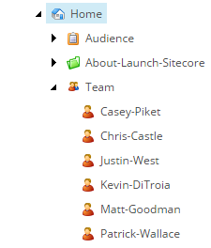

Once you install this module you will have a folder called Redirect Module in the System/Modules folder. This area will store all of your exact matches and patterns. Use the folder structure to organize your redirects and aliases. The module doesn’t use the folder structure for resolving items.

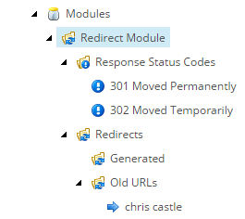

## Creating an Exact Match Redirect

First add a new Redirect URL item.

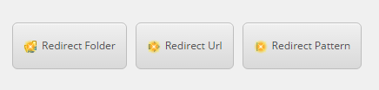

Now enter the Requested URL, the Status Code, and either a Redirect to Item or a Redirect to URL. Once this item is published, the supplied URL will resolve and return a redirect to the client to set the new location to the item. The notification bar at the top also provides a quick link to the redirect target.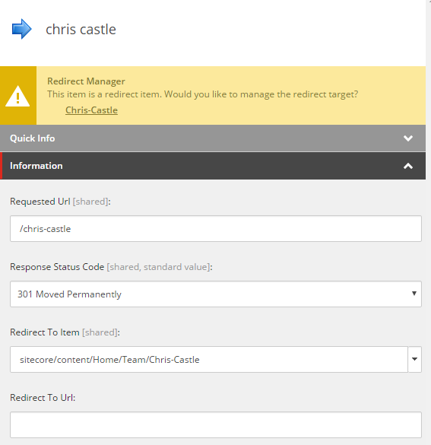

## Creating a Pattern Match Redirect

First add a new Redirect Pattern item.



Now enter the requested regular expression and the source item expression. Once this item is published, the supplied URL will resolve and return a redirect to the client to set the new location to the appropriate item. The URL in the browser will be redirected accordingly. If the Source Item path doesn’t return a valid Sitecore item, the redirect will not be sent and the user will receive the standard item not found page. This redirect type is used to move sections of your site.

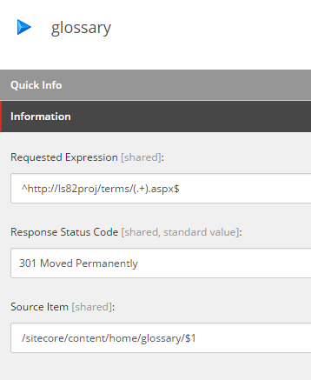

An example of a match here would be: http://ls82proj/terms/device.aspx will redirect to http://ls82proj/glossary/device

## Creating a Rule Based Redirect

First add a new Redirect Rule item.

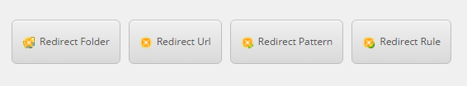

Now use the rules editor to create a redirect. Once this item is published, the supplied URL will resolve and return a redirect to the client to set the new location to the appropriate new URL. The URL in the browser will be redirected accordingly. This redirect type is used to move sections of your site. There is one action and one condition in the current implementation to do basic string detection and replacement. You can add additional rule actions and conditions to suit your specific needs.

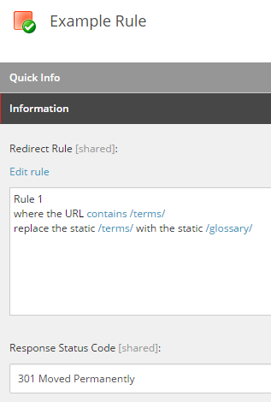

An example of a match here would be: http://ls82proj/terms/device will redirect to http://ls82proj/glossary/device

## Notifications

When you are navigating your site structure in Content Editor, you will see notifications on the items that are redirect targets. This serves three purposes:

1. Notify the user that this page is accessible through an old URL.
2. Allow the user to change the redirect URL or the target of the redirect.
3. Allow the user to remove the redirect.

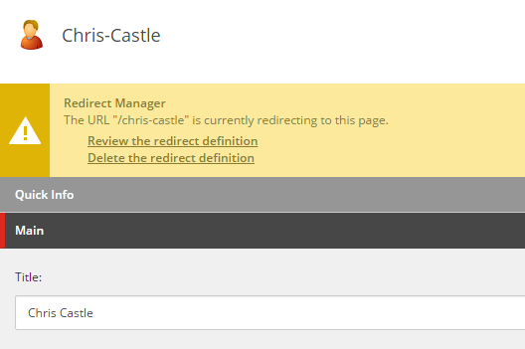

## Auto Generating Redirects as Pages are moved

The module supports automatically creating redirect definition items as pages are moved. This means that authors will not create broken links when they move pages. The redirects are stored in a bucket underneath the redirects root folder. This feature can be disabled in the config file.

## Configuring the Module

To use the module, you need to create your redirect rules and publish them. The main templates have all of the fields marked as shared, but you can also create versioned redirects.

There is a configuration file added to the App_Config folder to specify a few more settings. These include:

* The ability to turn off either type of redirect. For instance if you are not using regular expression patterns, it can be turned off.
* The module also allows you to specify the search type. Users can specify the search to use Sitecore Query, Fast Query, or the API GetDescendants() method. The best setting for your site depends on the number of rules implemented. Note: If you decide to version the fields in your templates, you should not use fast query.
* You can also move the Redirect Module node. You just need to specify the new location in the configuration file.
* The module also can automatically create redirects as items are moved. There is a Boolean setting in the config to enable / disable this feature. It is enabled by default.